STM32F103C8T6 Microcontroller Core Circuit + Circuit Explanation
The STM32 series processor is a 32-bit microcontroller produced by STMicroelectronics based on the ARM 7 architecture and supporting real-time emulation and tracing. This control chip was selected not because this system design pursues the lowest cost or the lowest power consumption, but because it can provide richer interfaces and functions under the premise of realizing the required functions of this design, making it easier to design the peripheral expansion circuits needed for each experiment in the experimental system. This control chip is relatively easy to learn after completing a microcontroller course, is widely used in medical devices, and has good value for learning and experimental research.
Main advantages of STM32:
(1) Uses the latest and advanced ARM Cortex-M3 core architecture
(2) Excellent real-time performance
(3) Outstanding power management
(4) Superior and innovative peripherals
(5) Maximum integration
(6) Easy development, enabling products to reach the market quickly
STM32 - the best platform option
For developing multiple projects on the same platform, STM32 is the best choice:
(1) From applications requiring only small memory space and few pins to applications requiring more memory and more pins
(2) From performance-demanding applications to battery-powered applications
(3) From simple, cost-sensitive applications to high-end applications
(4) High compatibility across the whole family in terms of pin-to-pin mapping, peripherals, and software, providing comprehensive flexibility. Without modifying your original hardware framework or software, you can upgrade your application to a device with more memory, simplify it to use less memory, or switch to a different package specification.
A microcontroller is what we often call a single-chip microcomputer. It is commonly used in control applications and is a very important part of microcomputers. In daily life, it is frequently used for control tasks. A microcontroller is mainly composed of a single integrated circuit. The most important internal parts are the CPU, I/O ports, and memory. By programming it with the appropriate compiler and downloading the program, we can control peripheral devices. The selected microcontroller design is based on the STM32F103C8T6 core board. The STM32 microcontroller is a low-voltage, high-performance microprocessor. It is simple, convenient, and easy to use. It is widely used in medical institutions and industrial production for real-time control, parking systems, computer peripherals, communication equipment, and other fields.
To realize system functions, the microcontroller must exchange information with the circuit or external functional modules. This requires pins to connect them and achieve communication, and these pins are also how the external characteristics of the microcontroller are expressed. With technological progress, microcontrollers have paid more attention to size and appearance, so many pins have been designed to be dual-function or multifunction.
STM32 features:
Operating frequency (MHz): 48
16-bit timers: 8
32-bit timers: 1
A/D converters: 1 x 12-bit
D/A converters: 1 x 12-bit
Communication interfaces: 1 x SPI/I2S; 1 x SPI; 2 x I2C; 2 x USART; CEC
I/Os: 39
Voltage (V): 2 to 3.6
The STM32F103 is an enhanced version of the STM32F101 and delivers among the strongest performance in 32-bit MCUs. It has excellent control and communication capabilities and is very suitable for low-voltage and low-power applications. The figure below shows the STM32 core.
The STM32103 is based on the ARM Cortex-M3 core specially designed for embedded applications requiring high performance, low cost, and low power consumption. Its clock frequency reaches 72 MHz, making it one of the highest-performance products in its class. It integrates 32 KB to 128 KB of Flash memory for code execution. STM32 power consumption is 36 mA, making it one of the lowest-power products in the 32-bit market, equivalent to 0.5 mA/MHz. STM32 has four P ports. SPI-NSS is the chip-select enable line.
SPI-MISO: data output; SPI-SCK: clock line; SPI-MOSI: data input.
STM32 microcontroller reset: the function of the reset circuit is to restore the system to its initial state. There are several reset methods for the microcontroller: power-on reset, system reset, and backup-domain reset. Power-on reset occurs when the system powers on, powers off, or returns from standby mode. Power reset can reset the state of all registers except those in the backup domain. System reset can be generated by any of the following events:
1. Low level on the NRST pin (external reset)
2. Window watchdog counter timeout (WWDG reset)
3. Independent watchdog counter timeout (IWDG reset)
4. Software reset (SW reset)
5. Low-power management reset
STM32 oscillation circuit: STM32 does not have an internal crystal oscillator; HSI is an internal RC oscillator. The error of the internal 8 MHz RC oscillator is about 1%, and its accuracy is usually much worse than that of HSE (external crystal). There is no absolute advantage or disadvantage; the most important thing is to choose according to the application scenario. When the clock requirement is not high, HSI can also be used. It should be noted that when HSI is used, the highest system clock frequency cannot reach 72 MHz. STM32 ISP uses the internal RC oscillator (HSI).
The STM32F103 microcontroller is a low-power, high-performance controller. Its role is to control various sensors and peripherals, calculate and process the acquired data and signals, and perform corresponding operations, acting as the brain in industrial production. Compared with daily-use computers, a microcontroller can only be regarded as a tiny integrated circuit system. Its function is limited and it can only handle relatively simple control tasks. Microcontrollers are used very widely. Most electrical appliances are controlled by microcontrollers, ranging from refrigerators, air conditioners, washing machines, and televisions to remote controls, mice, keyboards, and alarm clocks. Microcontrollers are widely used in instruments, aerospace, household appliances, and medical equipment. The development of intelligent devices also relies heavily on microcontrollers, and diversified sensors place new demands on them, so increasingly advanced microcontrollers continue to appear.
The selected microcontroller is the STM32F103C8T6. Compared with the 51 series, this microcontroller has many more functions. Not only is it much faster than the 51 microcontroller, but it also includes multiple ADC channels, which makes analog signal measurement very convenient because there is no need to add an external ADC for conversion.
STM32 has very powerful communication and control functions. This is something the 51 microcontroller cannot match. The 51 microcontroller has only one serial port for communication, whereas the 32-bit microcontroller has three serial ports. Therefore, for some modules requiring serial communication, there is no need to use dual-serial-port switching modules such as the CD4052 for conversion. This is one reason why it is widely used in the market. Because the 32-bit microcontroller itself can operate under multiple different clock modes, it also occupies an important place in products with strict power-consumption requirements.
STM32 features:
1. The oscillation crystal part of the STM32F103C8T6 series uses an RTC low-load approach instead of the traditional low-cost cylindrical crystal oscillator.
2. Number of pins: 48.
3. Operating frequency: 72 MHz.
4. The microcontroller has three general-purpose timers and one advanced timer.
5. The microcontroller has two 12-bit / 16-channel ADCs.
6. A 3.3V regulator chip is used, ensuring a maximum output current of 300 mA.
7. Supports ST-LINK and JTAG debugging/download.
8. Memory resources: 64 KB Flash and 20 KB SRAM.
Pin diagram of the STM32F103C8T6 microcontroller
Features of the selected STM32 core board:
1. Power indicator LED (PWR, usually red): if the power indicator LED is on, the microcontroller is operating normally; if it is dim or flashing, the microcontroller may be faulty.
2. User LED (PC13): this feature greatly facilitates simple function testing, such as checking the running status of the microcontroller, and is convenient for beginners.
3. Jumpers are used on the microcontroller board, allowing three programming methods for the STM32, such as user SRAM, Flash, and system memory.
4. Includes a microcontroller reset circuit.
5. 8 MHz crystal oscillator: mainly used to set the system frequency of the microcontroller to 72 MHz.
6. 32.768 kHz crystal oscillator: can be used by the built-in RTC, avoiding the need for a dedicated clock chip for timing functions.
- Most pins are brought out for convenient use.
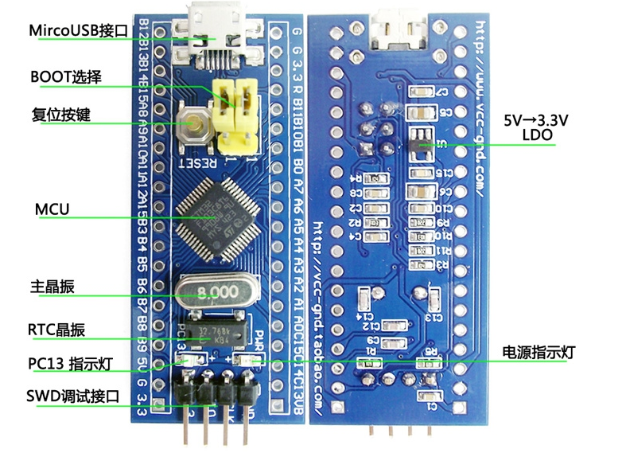
Core board overview
The internal circuit diagram of the STM32F103C8T6 microcontroller core board is shown below.
.
Internal circuit schematic of the STM32 microcontroller core board
The interface circuit diagram of the STM32F103C8T6 microcontroller core board is shown below.
Interface schematic of the STM32 microcontroller core board
The physical picture of the STM32 microcontroller is shown below.
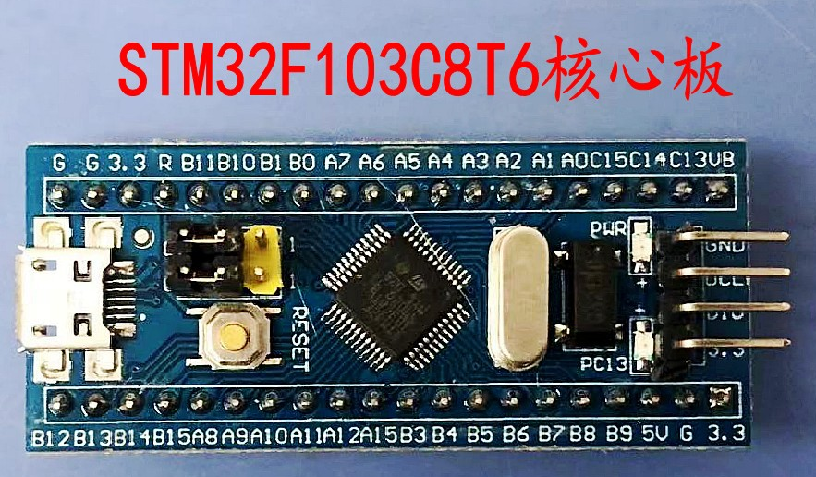
Physical picture of the STM32 microcontroller core board

